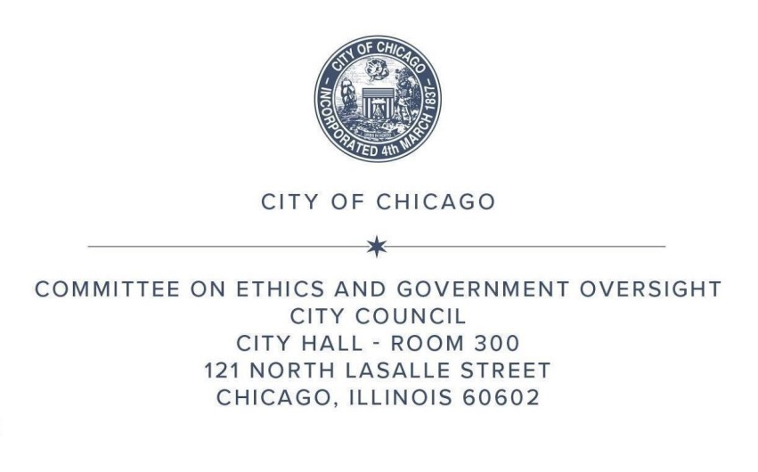
SUMMARY OF REPORTS
COMMITTEE ON ETHICS AND GOVERNMENT OVERSIGHT
TO BE SUBMITTED TO THE CITY COUNCIL
AT THE MEETING ON
TUESDAY, MARCH 18, 2025

PASSED COMMITTEE:
March 18, 2025

- January 2025 Rule 45 Monthly Report of the Committee on Ethics and Government Oversight.
SUBJECT MATTER HEARINGS (No votes taken):
- The Committee on Ethics and Government Oversight held a subject matter hearing on March 18, 2025, to discuss the Office of Inspector General’s quarterly report on the Fourth Quarter of 2024.
- The Committee on Ethics and Government Oversight held a subject matter hearing on March 18, 2025, to hear updates from the Office of Inspector General and Department of Water Management about the advisory on Non-Compliant Separation of Water Mains and Sewers.

