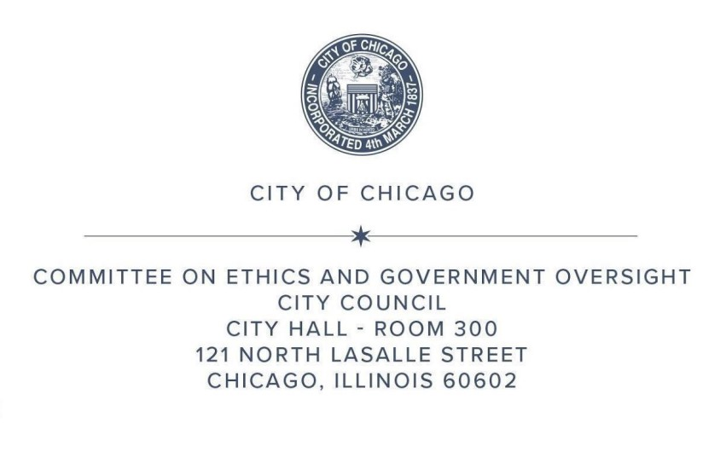

**AGENDA OF MATTERS**

**COMMITTEE ON ETHICS AND GOVERNMENT OVERSIGHT**

**MONDAY, MAY 5, 2025, AT 12 PM**

**ROOM 201A, SECOND FLOOR, CITY HALL**

<https://www.chicityclerk.com>

**RULE 45 REPORT**

1. Approval of the March 2025 Rule 45 Report for the Committee on Ethics and Government Oversight.

**BOARD OF ETHICS**

1. Appointments to the Board of Ethics

**SUBJECT MATTER HEARINGS**

(*No votes taken*)

**OFFICE OF INSPECTOR GENERAL**

1. Quarterly Report: First Quarter 2025 (*released April 15, 2025)*
2. Audit and Program Review Section 2025 Annual Plan (*released February 19, 2025*)

This Committee will host public comment at the beginning of the Committee Meeting. Each person participating in public comment shall have up to three minutes to address all items on the agenda during this public comment period. The Committee will not conduct separate public comment for each agenda item. The public comment period will be limited to 30 minutes overall, with each participant limited to three minutes. Due to the high demand, the Committee cannot guarantee every person who signs up for public comment will have the opportunity to speak. For those who wish to speak during public comment, instructions for remote participation are outlined and posted on the Chicago City Clerk’s website [<http://www.chicityclerk.com/>].