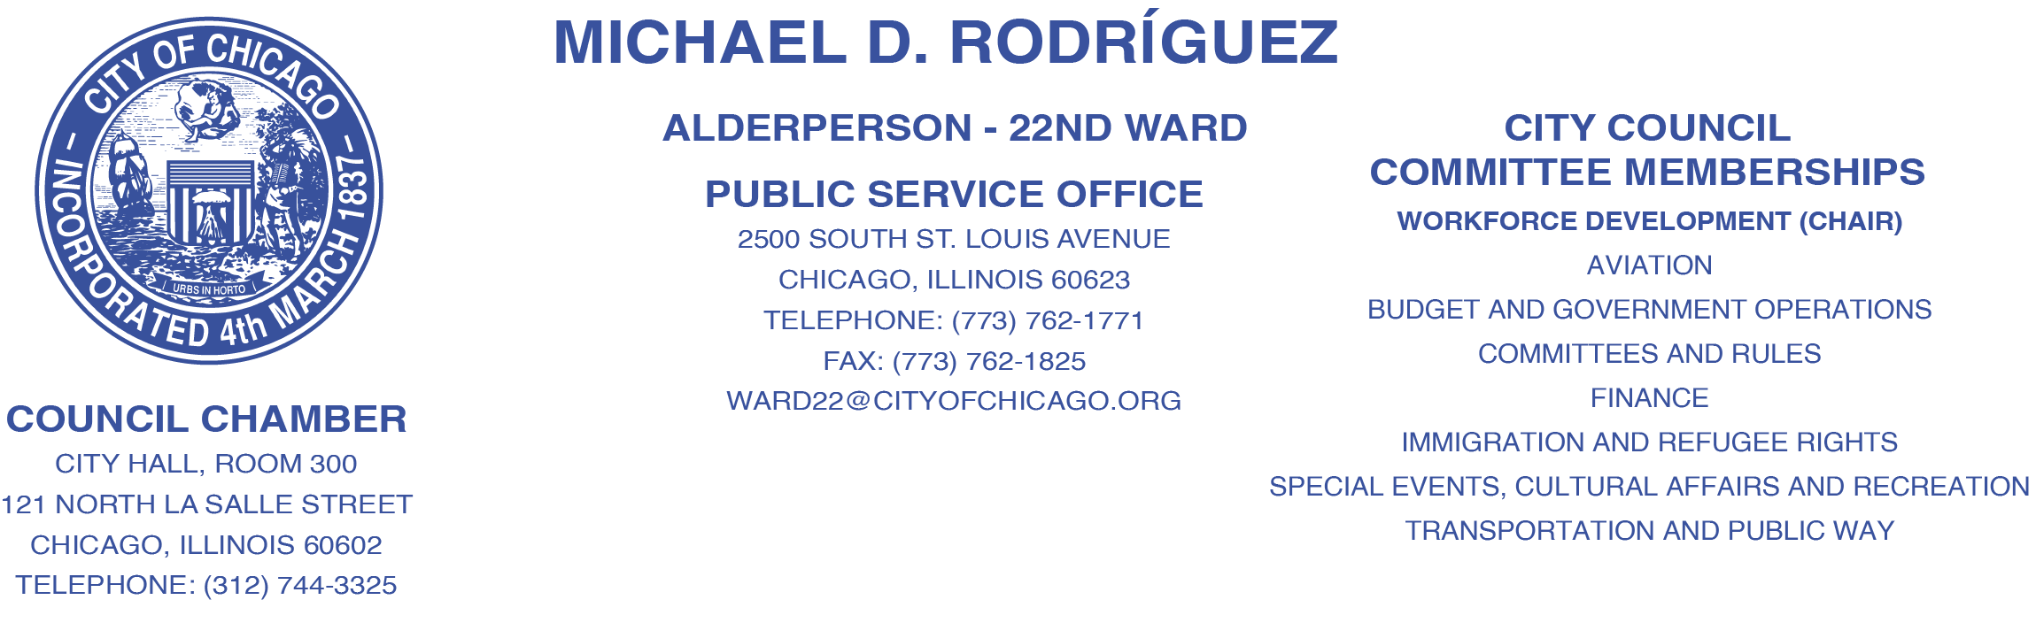

AGENDA OF MATTERS TO BE CONSIDERED
BY THE COMMITTEE ON WORKFORCE DEVELOPMET
THURSDAY, SEPTEMBER 7th, 2023
9:30 AM
CITY HALL, SECOND FLOOR, COUNCIL CHAMBERS
Written public comment on any of the items listed on the Agenda will be accepted at CommitteeonWorkforceDevelopment@cityofchicago.org until 10am Wednesday September 6th, 2023.
Items to be Considered:
- Approval of July Rule 45 Report

- Direct Introduction: An ordinance authorizing the execution of Collective Bargaining Agreements between the City of Chicago and the Illinois Nurses Association (INA), the Illinois Council of Police (ICOP), the Coalition of Unionized Public Employees (COUPE), and several named trade unions.

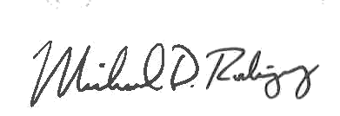
______________________________
MICHAEL D. RODRÍGUEZ, CHAIRPERSON
COMMITTEE ON WORKFORCE DEVELOPMENT

