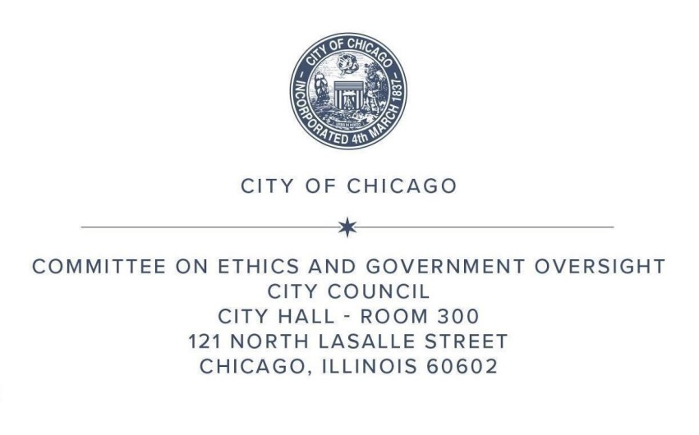
MONTHLY RULE 45 REPORT
MARCH 2025

Pursuant to Rule 45 of the City Council Rules of Order, the Committee on Ethics and Government Oversight submits the following report for the meeting held on March 18, 2025.
Attendance
The following committee members were present at the January 18 meeting: Chair Martin (47), Vice Chair Hadden (49), O’Shea (19), Taliaferro (29), Waguespack (32), Sposato (38), Nugent (39), Vasquez (40), and Lawson (44).
The following non-members were also present: Burnett (27) and Cardona (31).
Meeting Opening
Roll call was taken and a quorum established. The Chair opened the floor for public comments, and there were five public speakers and one written comment.
Rule 45 Monthly Report for October 2024
Vice Chair Hadden moved to approve the Rule 45 Monthly Report for January 2025, which reflected the last committee meeting held on January 28, 2025. The motion passed unanimously by an affirmative voice vote. Approved by Committee March 18, 2025.
The Committee on Ethics and Government Oversight addressed the following items:
- Subject Matter Hearing: Quarterly Report: Fourth Quarter 2024.
- Chair Martin introduced the following witness to provide testimony:
  - Inspector General Deborah Witzburg.
- Chair Martin opened the floor for Alderpersons to ask questions and provide comment. The following committee members asked questions or made comments: Martin, Lawson, Waguespack, Sposato, Hadden.

- Subject Matter Hearing: Office of Inspector General Advisory on Department of Water Management Non-Compliant Separation of Water Mains and Sewage
- Chair Martin introduced the following witnesses to provide testimony:
  - First Deputy Commissioner Joel Vieyra;
  - Chief Engineer Hans Krueger; and
  - Inspector General Deborah Witzburg,
- Chair Martin opened the floor for Alderpersons to ask questions and provide comment. The following committee members asked questions or made comments: O’Shea, Sposato, Waguespack, Martin.

Meeting Closing
The Committee having no further business, Alderman O’Shea moved to adjourn. Chair Martin adjourned the meeting.

